

School-to-Work

Apprentice Program

A picture containing clipart

Description generated with high confidence

**Inaugural Class**

**2019-2020**

Student Rotations Start Aug 2022

15-20 hours per week (4 days per week)

12-week work rotations

Students are paid team members

**This a program is where you will learn what you want to do and what you don’t want to do for a career. You can approach this great opportunity as early career exploration after high school graduation. Many people have gone to college and are undecided on what to major in, but this program will let you explore your options for 2-years in a hospital. If you decide not to attend college, you will still learn key skills to work in healthcare and possibly find a trade.**

**You will develop skills needed to be competitive in a healthcare job market.**

**You will rotate to a different department each quarter which is selected by the Manager and School to Work team. By rotating to various departments, you will learn different skills, see how each department operates and your experiences can assist in helping you to make a good career choice.**

**TriHealth will directly benefit from the work performed by students.**

*“Teenagers are very inwardly focused. Concerned about what others think of them. Cell phones help perpetuate that condition. This opportunity will help you to be more outwardly focused on others and supporting their needs”*

Kathy Wright

Hughes STEM Principal



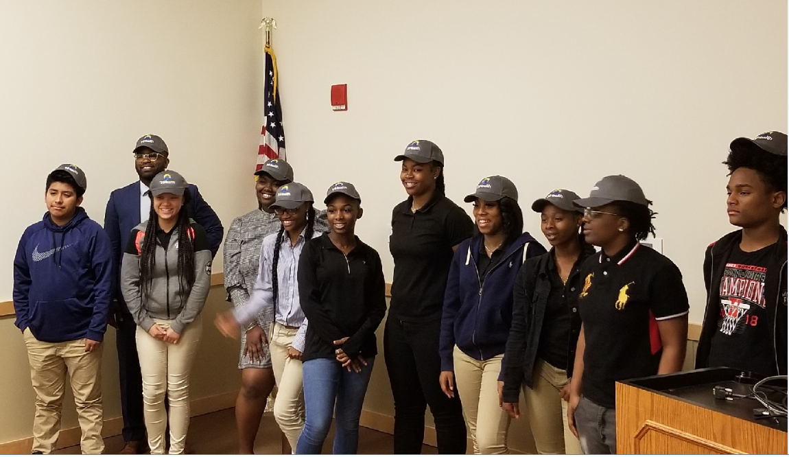

**The goal of the School-to-Work Program is to inspire diverse and underserved high school students to a career in healthcare by giving them real-world working experience and access to mentorship over a two-year work commitment at TriHealth (starting with a pilot at Good Samaritan Hospital then spreading throughout the system). This program will create the foundation for the student to explore careers in healthcare, build job skills, and contribute financially to their community and family. School-to-Work aims to increase diversity and inclusion at TriHealth as well as engage team members through mentorship opportunities.**